James Wilson
ES/JHS ALT – Sado
2016 Niigata SDC
Activity Exchange - For JHS

Civil Rights Movement Reading Lesson
Ruby Bridges
Lesson Overview

Target Grade Level: Junior High School 3rd Year
Total Estimated Time: 30-50 minutes

JTE Involvement
- How much the JTE is involved in this lesson plan depends a lot on them, as well as your own confidence. I have three JTEs and they all have been involved at varying degrees. One stood in the back the whole time and said nothing, while another has stood at the front with me aggressively urging the students to contemplate the meaning of the lesson. This is something that you need to discuss with them right from the beginning.

- Warm-Up
- 10-15 minutes
- Imagination Shiritori – in shiritori people make a string of words where each word must begin with the letter of the previous word. However, in Imagination Shiritori the previous word’s spelling has no effect. The objective is to continue the chain with a word that has some relation to the word before it.
Ex: Sky Blue Ocean Seafood Sushi
Split the students into groups, write the first word to start from, and the group with the most correctly spelled words after 1-2 minutes wins. However, in order to get kids thinking about concepts similar to those of the Civil Rights’ Movement, I wrote words such as free, equality, freedom, friendship. This can be done on paper, white boards, or the blackboard.

- Short Introduction
- 5-10 minutes
- The majority of the kids are aware of the past and present segregation and discrimination of non-white people in the States (and elsewhere) , but they don’t seem to know many details. I do a short presentation describing to what lengths the segregation was enforced. I showed pictures of restrooms, drinking fountains, waiting rooms, classrooms while talking about their treatment as secondary citizens.
- Reading and Answering Questions
- 10-15 minutes
- Pass out a worksheet to each student and allow them to work on the article in pairs or in groups. Confirm the vocabulary at the bottom and possibly the sentences/questions on the backside. On the attached copy, there are only 5 True/False sentences written, but the amount and types of questions can be altered to better fit your class’s abilities. Walk around assisting them when needed and allow them to complete the reading and answers.

- Checking the Answers
- 5-10 minutes
- To encourage more of the students to put effort into the activity you can have them write their answer(s) on the board. Alert them to this fact, but do not tell them which question(s) they will be doing. Go through their answers one by one and verify with them where in the passage the answers are found. I’ve found that if you can or if you can get your JTE to ask further questions (e.g. Why Ruby Bridges was alone in #5?; Why the parents didn’t want her in the white schools?; etc.) the students get a more solid understanding of discrimination. Usually this has to be done in Japanese.

- Closing Statements
- If there is time, I try to comment on the fact that racial discrimination still exists and is still a serious problem certainly in the States but also throughout the world. And ask students if they can think of examples of or ideas to help change discrimination. This last part depends greatly upon the JTE, (whether they are open to encouraging students to think about this sort of stuff or whether they have time in their academic plan) and your own Japanese abilities.

Year:_____ Name:_______________________________
The Bridges Between White and Black
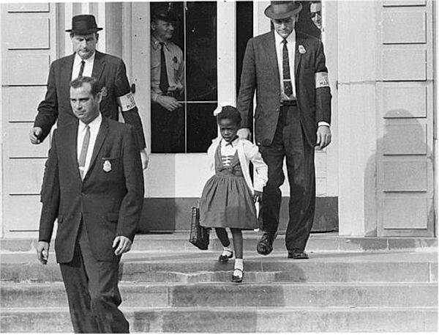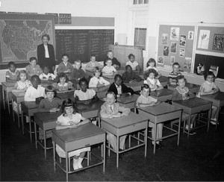
A long time ago, some people thought that black people and white people shouldn’t be friends. In some places, white children and black children couldn’t go to the same schools. I am Ruby Bridges and I am glad to change that.
I’m from Louisiana in the U.S.A. In 1960, I went to an all black school. I liked my school, I liked my teacher, and I liked my friends. But there was a school for white children that was near to my house. And the government said, ‘Ruby Bridges can go to that school.’ So, when I was in first grade, my mother took me to the all white school. Some people didn’t want me to be there. The police came with us to protect us. The white parents didn’t like me, so they took their children out of school because I was there. I was alone with my teacher, Mrs. Henry. Months and months later, children began to come back to school. Finally, I had friends to play with. I was very happy! Now, black kids and white kids can be in the same school together.
I believe that all kids should be friends. We have to give each other a chance. And I hope that my story will help other kids and give them a chance, so we can be friends and no one will feel like I felt in 1960, when I was alone. Mrs. Henry and I gave each other a chance. We were friends then and we are still friends today. What you look like is not important. What is inside is important.

Words

Government - 政府

‘…didn’t want me to be there…’ - そこにいてほしくないと思う

Alone - 一人ぼっちで
Below there are sentences about the reading.
Please write an O if it’s correct or an X if it’s wrong.

- In 1960, black children and white children went to the same schools.
_______

- The name of the little girl is Ruby Bridges.
_______

- She was the first black child to go to an all white school.
_______

- The parents of the white children were happy to see Ruby Bridges.
_______

- Ruby Bridges spent only 1 week alone with her teacher, Mrs. Henry.
_______

