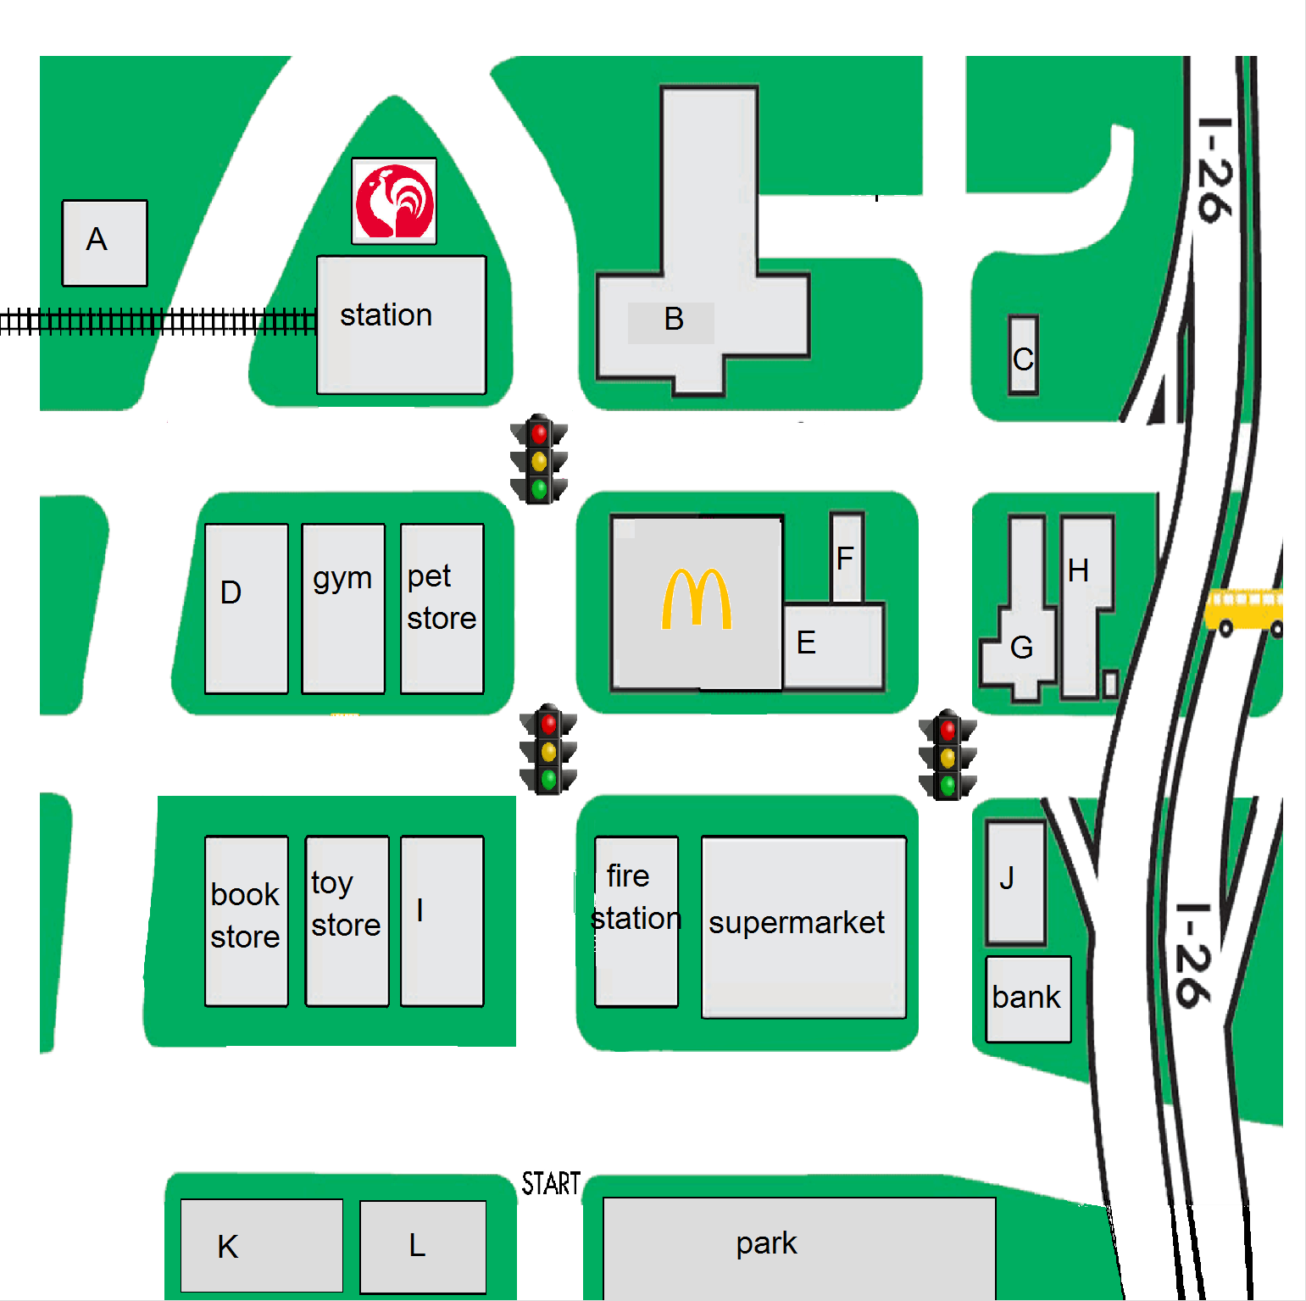
- How do I get to the library?
-Go straight until the light. Turn right, then walk for one block. Building____
Turn left at the next light. The library will be on your right.

- Could you tell me the way to the department store?
-Go down this street and turn right at the second light. Building____
The department store is across from McDonald’s.

- Could you tell me the way to the convenience store?
-Turn right and go down this street until the bank. Turn left and Building____
walk until the first light. You’ll see the building on your right.

- How do I get to the post office?
-Go straight until the second light. Then, turn left. Go straight Building____
and you will see the building on your left, next to the gym.

