Name:________________________ Date:_________________________________ Class:_________________

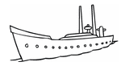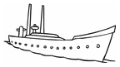

In your fleet, you have….
                                                      
ONE BATTLESHIP ONE SUBMARINE TWO CRUISERS
YOU
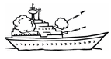 | 6:00 am? | 8:30  am? | 4:45  pm | 7:15  pm? | 10:30 pm?
Do you wake up at…
Do you go to school at…  HIT |  |  |  |  | MISS
Do you play sports at…
Do you eat dinner at…
Do you go to bed at…
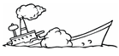
YOUR OPPONENT
 | 6:00 am? | 8:30  am? | 4:45  pm | 7:15  pm? | 10:30 pm?
Do you wake up at…
Do you go to school at…
HIT

Do you play sports at…
Do you eat dinner at…
Do you go to bed at…

