Can you play soccer ?
O: Yes, I can
X: No, I can’t
Start
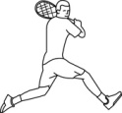

play tennis
speak Korean
cook

swim

play piano

play baseball

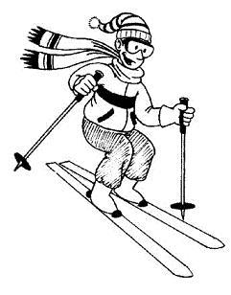
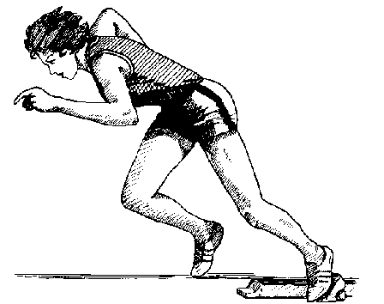

run fast
ski

speak English

Finish!
What can you do?
Write about your friend.
れい。 Richard can play soccer .
1. _____________________________________________
2. _____________________________________________
れい。 Richard can't speak Korean .
3. _____________________________________________
4. _____________________________________________
Write about you.
れい。 I can play soccer .
5. _____________________________________________
6. _____________________________________________
れい。 I can't read kanji .
7. _____________________________________________
8. _____________________________________________

JHS 1 year “Can you ------?” pg. 80-83

First Activity: Evolution Janken
- Everyone starts at the first question (Can you play tennis?)
  - Both partners ask their question, answer, then janken
- If you win, you level up to the next question (Can you speak Korean?)
- The winner is the first to get to the Finish.
I usually do a couple of examples with the HRT, then practice all the questions together before starting. I then give stickers to the 5 fastest people.
Second Activity: Interview
- First have the students choose two more “Can you ----?” questions and write them on the sheet.
- Interview with the person next to them, writing a O for yes I can, or an X for no I can’t.
- Have every other column move up one seat so they have new partners.
- Repeat 4 times.

Some students are not creative and may need some help coming up with the questions.

Third Activity: Writing Activity
- Students use the results of the second activity to write about their friends. Then they write about what they can and can’t do.

