Junior High School – any year level Duration : 15-20 minutes

Have you played Cluedo/Clue? This is a classroom adapted version! The objective is for students to guess the three picture cards that you have in your envelope.

The example below shows grade 2 grammar but you can adapt it to many other grammar structures! You just need 3 elements to the sentence structure you are working with.

Print out a worksheet (like the one attached) for the number of pairs/threes you have in the class. Also print one copy for you and one for your JTE. You and your JTE’s copy should be cut out into 15 small picture cards. Then, you must choose one picture from the left hand column, one from the middle and one from the right and place them in an envelope. Make 2 envelopes containing the same picture cards; one for you and one for your JTE. Keep the remaining cards that you cut out and take them with you to class. You and your JTE will use them in the activity.

For the sake of explanation, let’s say I put the following picture cards into an envelope:

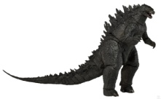  Godzilla |  | India |  | dance

Students work in pairs taking it in turns to come up to the teacher and ask a question using the target grammar. They will choose one picture from each column and then make a question using the suggested format at the top of the worksheet.
If a student asks, “Will Godzilla go to India to dance?” then the teacher will respond with “Yes, he will.” First team to guess is the winner! (I’m yet to have a student guess it first go!)

If they do not get all 3 aspects of the sentence correct, the teacher will respond with “No, he/she won’t”. Using the remaining cards that weren’t put into the envelope, the teacher will show the student one aspect of their constructed question that is wrong. E.g. If the student asks, “Will Godzilla go to Canada to dance?” the teacher would show them a picture of Canada. If the student has more than one part that is incorrect, the teacher will choose one image to show them. E.g. If the student asks, “Will Godzilla go to Sydney to watch a concert?”, the teacher can choose to show them the Sydney card or the watch a concert card.

Some groups/pairs will finish earlier than others. To avoid idle time, my JTEs and I do the following. For game 1, both teachers have the same contents in their envelope. However, once Game 1 produces a winner, I start game 2, changing the contents of my envelope. Students continuing with Game 1 go to the JTE, while those starting Game 2 come to me. You can choose to finish the activity whenever you feel is right.

Will Mickey Mouse go to Sydney to take a picture?
Guess the correct question!

Mickey Mouse | Sydney | take a picture
Hello Kitty | Tokyo | buy a handbag
Totoro | China | dance
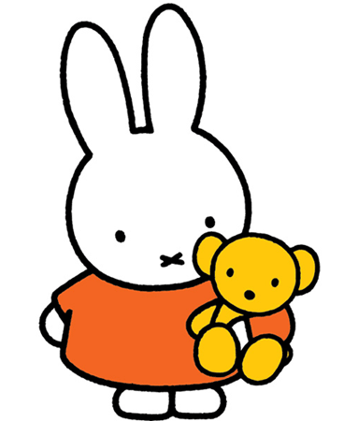  Miffy | India | eat chocolate
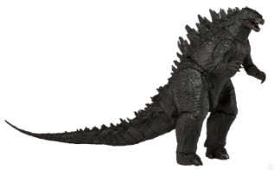  Godzilla | Canada | watch a concert

