JHS LESSON PLAN
A.SMITH
GRADE: 3rd JHS
SOURCE MATERIAL: From a JTE who I worked with 2 years ago
DURATION: 50 mins
ALT ROLE: Facilitator
JTE ROLE: Facilitator and translator
INTRODUCTION
This activity is designed to get away from making worksheets and using endless ideas from Englipedia or any other ESL website. It focuses on getting the students and the teachers to think outside the box.

ACTIVITY
A) Introduce the Grammar point "This is a car made in Japan"
Intro: Play a quick Karuta game using 10 cards.
1. This is a car made in Japan. Toyota
2. This is a food made from rice Onigiri
3. This is a fruit eaten in Summer Watermelon
e.t.c

B) The students now have some ideas of things to draw and introduce to you as a new ALT in Japan (pretend you don’t know). This is a good cultural lesson for you and for them to teach you about things they care about. Make it into a book for everyone to enjoy!
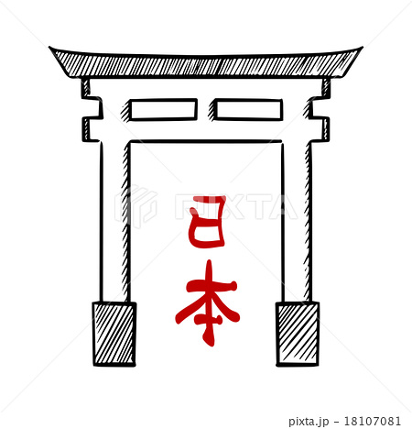

This is a Tori gate made in Kyoto. It is made from wood. There are many different kinds of Tori in Japan.

