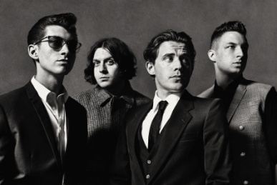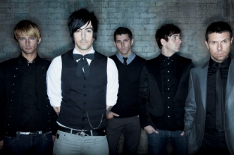

**Task 2 Make more sentences!**

Example: Song D is **the fastest**.

1. Song ___ is the ________________________.
2. Song ___is the _________________________.
3. ______________________________________________________.
4. ______________________________________________________.
5. Song ___ is ______________________________than song ____.
6. Song ___is ______________________________ than song ____.
7. ______________________________________________________.
8. ______________________________________________________.

**Song B**

Amy Winehouse – Love is a losing game

**Memo**

**Toolbox!**

Loud Quiet Calm Wild

Happy Sad Angry Weird

Fast Slow

**Task 1 Make sentences!**

Example : Song D is **angrier** than Song B.

**Song A**

Arctic Monkeys – I bet that you look good on the dance floor.

**Song D**

Lost Prophets – Last Train Home

**Song C**

Lily Allen – Knock ‘em out

|  |  |  |
| --- | --- | --- |
| Song | YouTube views | Awards |
| **Song A** | 12,000,000 | 3 |
| **Song B** | 19,000,000 | 1 |
| **Song C** | 2,000,000 | 0 |
| **Song D** | 7,000,000 | 0 |

1. Song ___ has **more** YouTube views than song ____.
2. Song ___ has **more** YouTube views than song ____.
3. Song ___ has **the most** YouTube views.





I like song ___ **the best** because it is ___________________ than the other songs.

It is also _______________________________________________.

________________________________________________________________________________________________________________________________________________________________________________________________________________________________

I like song ___ **the best**.

I like song ___ **better than** song ___.

I like song ____ **the least**.

1. Song ___ has won **more** awards than song ___.
2. Song ___ has won **more** awards than song ___ and song ___.
3. Song ___ has won **the most** awards.