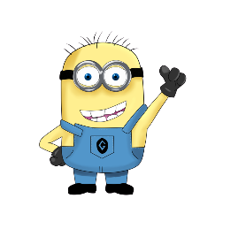
Name: __________________________________________ Class: __________
Mastermind
Make a secret sentence from the list at the bottom of the page.
_ _ _ _ _ _ _ _ _ _ _ _ _ _ _ _ _ _ _ _ _ _ _ _ _ _ _ _ _ _ _ _ _ _ _ _ _ _ _ _ _ _ _ _ _ _ _ _ _
My Secret Sentence:
I want to _______________ _______________ _____________ _______________
(verb) (object) (place) (time)
_ _ _ _ _ _ _ _ _ _ _ _ _ _ _ _ _ _ _ _ _ _ _ _ _ _ _ _ _ _ _ _ _ _ _ _ _ _ _ _ _ _ _ _ _ _ _ _ _

Guess your partner’s sentence. Write your guesses below.
Do you want to... | Verb | Object | Place | Time | How many correct?
 |  |  |  | ?
 |  |  |  | ?
 |  |  |  | ?
 |  |  |  | ?
 |  |  |  | ?
 |  |  |  | ?
 |  |  |  | ?
 |  |  |  | ?
 |  |  |  | ?
 |  |  |  | ?

Verb | Object | Place | Time
Wear | a Hat | At school | In the afternoon
Buy | a Kangaroo | At the beach | Tomorrow
Ride | a Sandwich | At home | On Thursday
Eat | a Bicycle | In the park | After class

