2nd Grade

*Show me your* hand.

Name: _____________________________________________________ Class: ________ Number: ________

Ask your friends to show you their hands. Use the drawing to read their fortune. Use this sentence pattern.

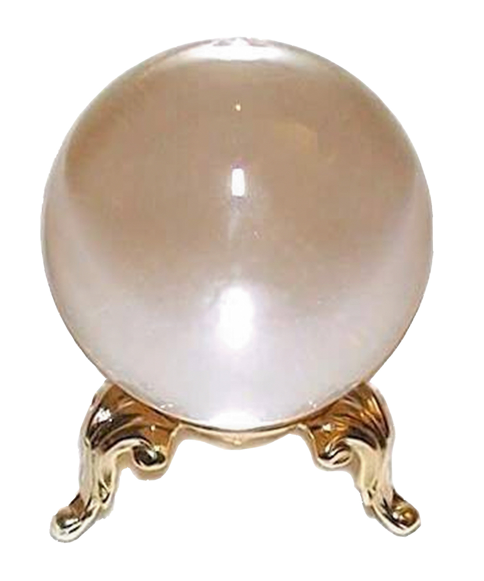

A: Show me your hand. B: OK. / Sure.

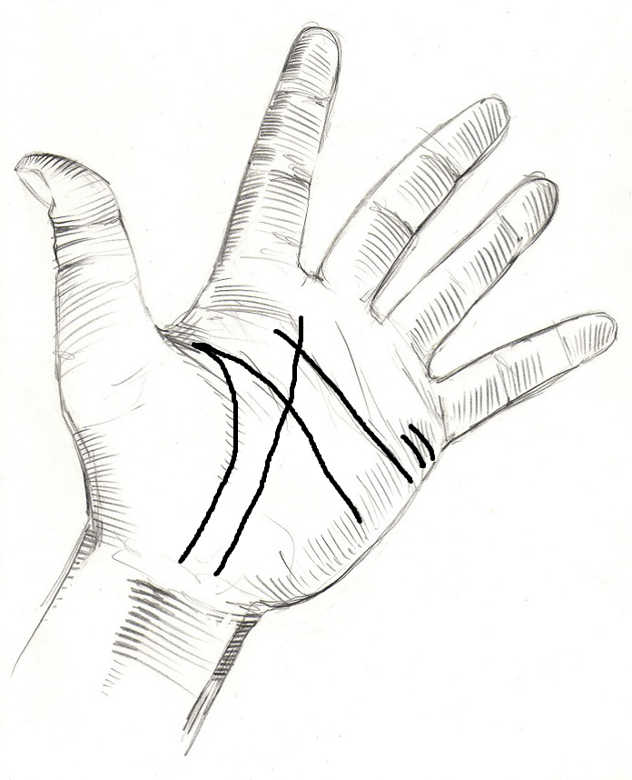

Line 1: The money line – If this line is long you are going to have a lot of money.

Line 2: The fame line – If this line is long you are going to be very famous.

Line 3: The head line – If this line is long you are going to be very smart.

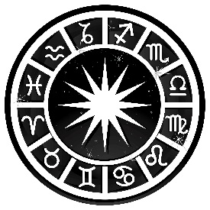

Line 4: The love line – If this line is long you are going to be in love for a long time.

Line 5: The child lines – If you have a lot of lines then you are going to have many children

|  |  |  |  |  |  |
| --- | --- | --- | --- | --- | --- |
|  | Are you going to have a lot of money? | Are you going to be very famous? | Are you going to be very smart? | Are you going to be in love for a long time? | Are you going to have many children? |
| My answers |  |  |  |  |  |
|  |  |  |  |  |  |
|  |  |  |  |  |  |

Use the words in the brackets to make correct sentences. Write your answers on the lines.

1: _______________________________________________________________________________________

(homework / me / . / show / your)

2: _______________________________________________________________________________________

(bag / show / your / . / me)

3: _______________________________________________________________________________________

(me / . / a / bring / pencil)

4: _______________________________________________________________________________________

(give / . / me / pen / a)

5: _______________________________________________________________________________________

(picture / his / . / Ichiro / showed / me)

Write your own, original sentences on the lines. Use this sentence pattern. Use the words in the box to help you.

*Show* me your camera.

1: _______________________________________________________________________________________

2: _______________________________________________________________________________________

3: _______________________________________________________________________________________

4: _______________________________________________________________________________________

5: _______________________________________________________________________________________

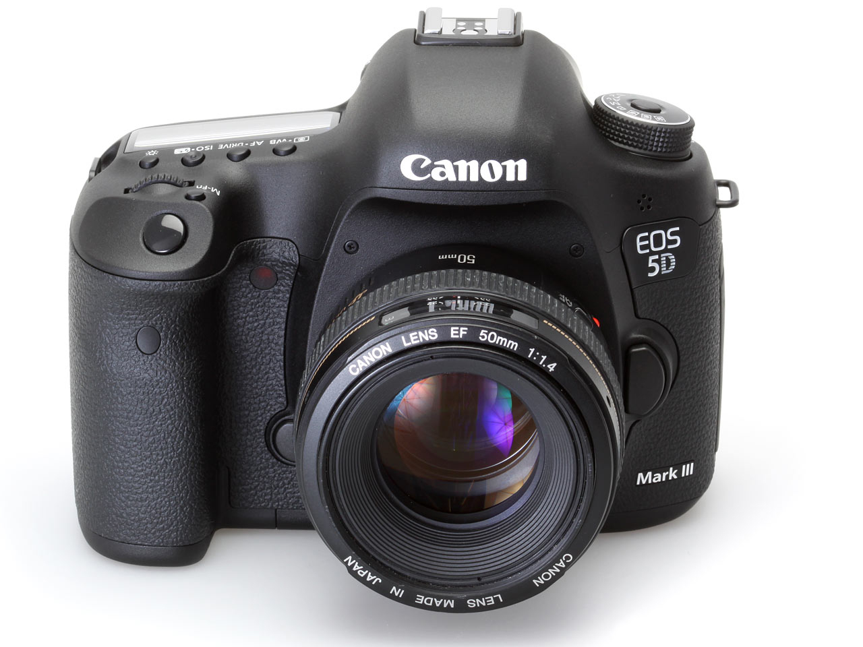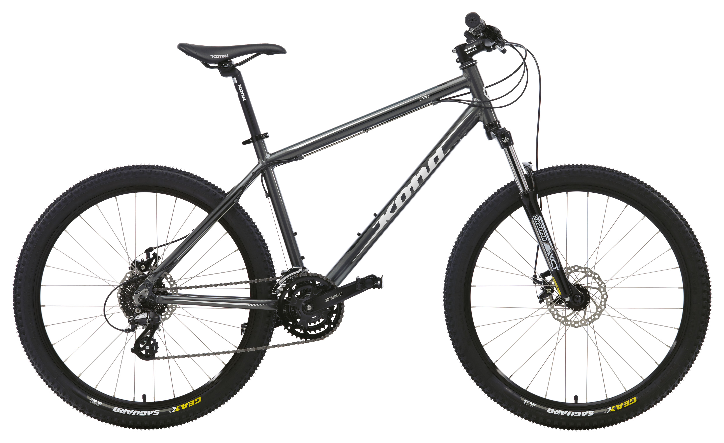

*show bring give buy*

me my friend my sister Kevin

a bike a camera your book a pen that picture