

1. ( ) 2. ( ) 3. ( )

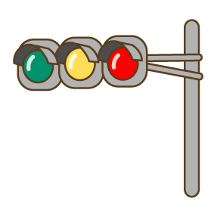

4. ( ) 5. ( ) 6. ( )

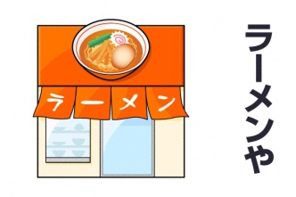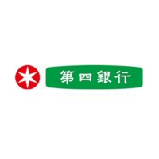

?

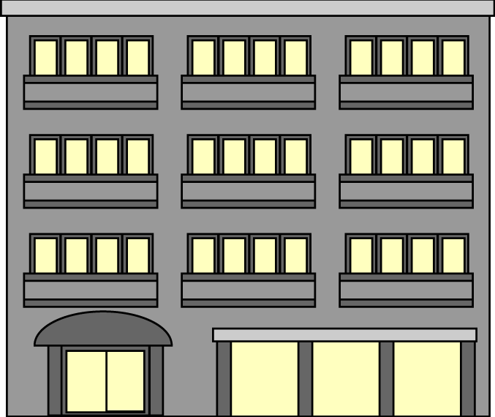

Bank



?

?



Bank

http://www.city.niigata.jp/info/kocho/tegami/21tegami/img/gakusei2.jpg

7. ( ) 8. ( ) 9. ( )



Bank

Post Office

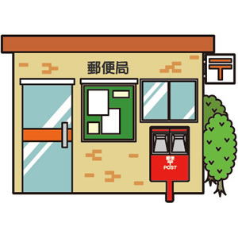

?

Bank

Post Office





10. ( ) 11. ( )

Use the Word Bank and write the correct English word in the blanks:

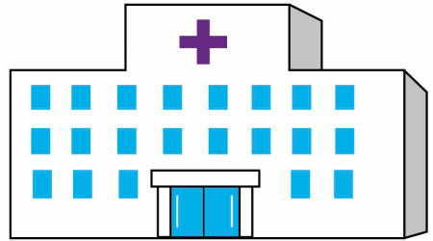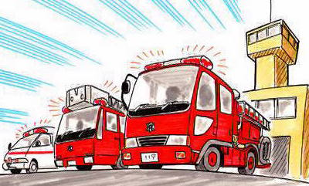

1.( ) 2. ( ) 3. ( )

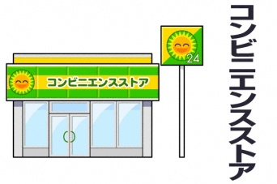

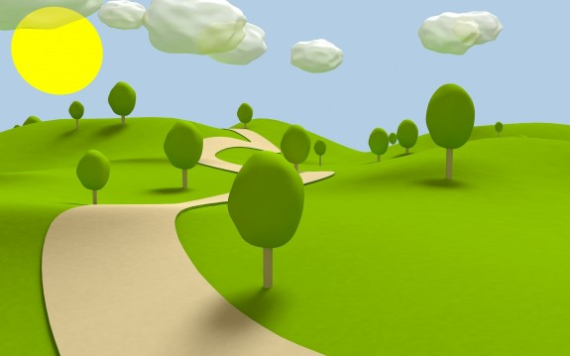

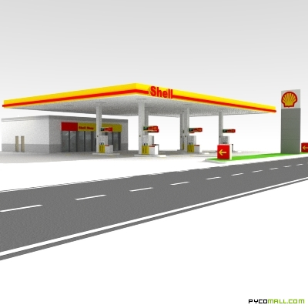

4.( ) 5. ( ) 6. ( )

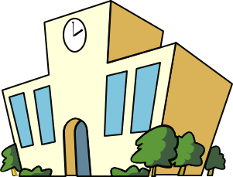

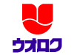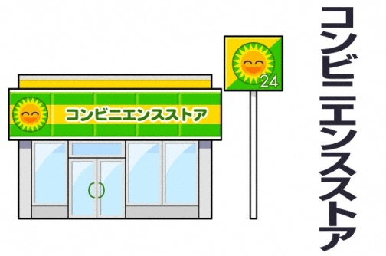

**UOROKU**

CD, DVD Rental

**TSUTAYA**

[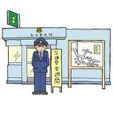](http://www.google.com/imgres?imgurl=http://blog-imgs-29-origin.fc2.com/s/o/l/solt324/s_05.jpg&imgrefurl=http://solt324.blog78.fc2.com/blog-entry-15.html&usg=__ErJWmAuK3QuyEy-Ntx5yIFyzlmY=&h=768&w=768&sz=97&hl=en&start=4&zoom=1&um=1&itbs=1&tbnid=Tc_zC1N_Vpm6IM:&tbnh=142&tbnw=142&prev=/search?q=%E4%BA%A4%E7%95%AA&um=1&hl=en&biw=1259&bih=598&tbm=isch&ei=Z5r6Tde9CobwvwPLk_WVAw)

7.( ) 8. ( ) 9. ( )

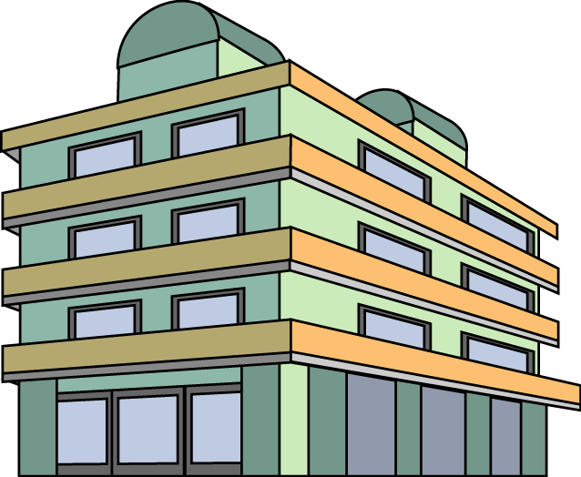

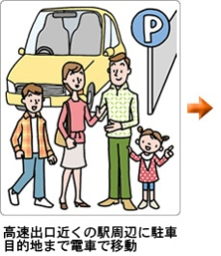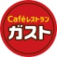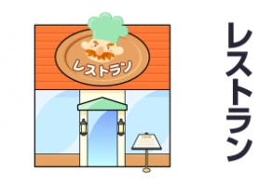

[](http://www.google.com/imgres?imgurl=http://blog-imgs-29-origin.fc2.com/s/o/l/solt324/s_05.jpg&imgrefurl=http://solt324.blog78.fc2.com/blog-entry-15.html&usg=__ErJWmAuK3QuyEy-Ntx5yIFyzlmY=&h=768&w=768&sz=97&hl=en&start=4&zoom=1&um=1&itbs=1&tbnid=Tc_zC1N_Vpm6IM:&tbnh=142&tbnw=142&prev=/search?q=%E4%BA%A4%E7%95%AA&um=1&hl=en&biw=1259&bih=598&tbm=isch&ei=Z5r6Tde9CobwvwPLk_WVAw)

10. ( ) 11. ( ) 12. ( )

**Word Bank:**

school café restaurant fire station park

gas station post office book store parking lot

supermarket apartment building convenience store hospital