十日町市教育委員会
国際交流員 Adam Barnett
2015 SDC “Mandatory Homework Assignment” (JHS)

Where’s Wally modifying clause activity. (3rd Grade/30 mins)
- This activity is designed to practice use of ‘–ing’ in noun modification (Total English 3 pg. 54).
E.g. Can you find the woman wearing a red skirt?

Materials Needed:
- Level 1-3 ‘Where’s Wally?’ worksheets.
- Blank ‘Where’s Wally?’ worksheets and question worksheet.

Method:
- Students race to complete levels 1 to 3 in pairs. The first pair to complete all 3 levels wins.
- Starting from level 1, students must put a ring around the 3 people being described in the text box.
- After they complete a level, they bring it to the ALT/JTE for checking, if they have answered right they can progress onto the next level.
- Once all 3 levels have been completed, students receive a blank ‘Where’s Wally?’ sheet and create their own questions using the grammar point.
- This time the students bring the questions they have completed along with the blank ‘Where’s Wally?’ sheet to the ALT/JTE to complete.
- During the activity, students can ask the ALT for vocabulary etc. that they do not know.

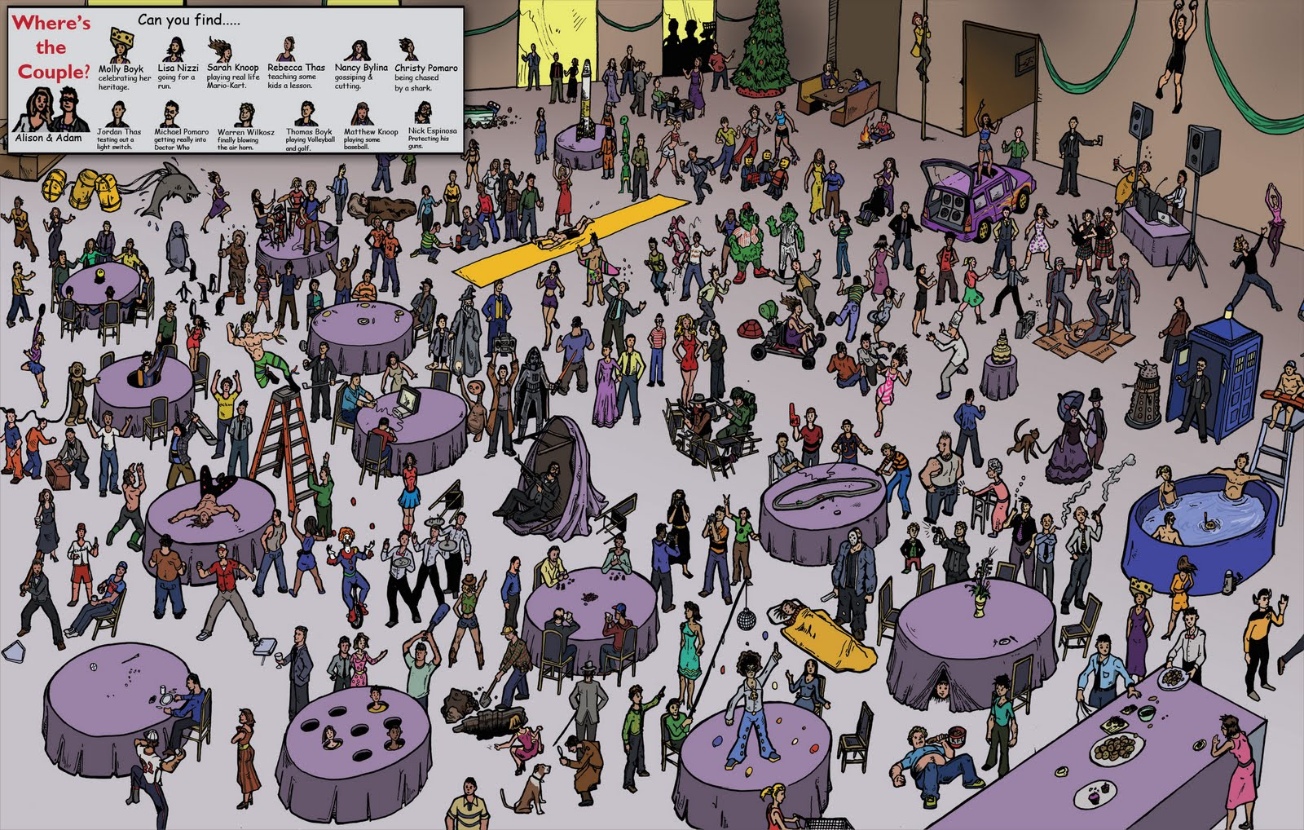
Level 2!
Can you find…
① a man dancing on a table?
② a woman with cheese on her head?
③ a man holding a baseball bat?

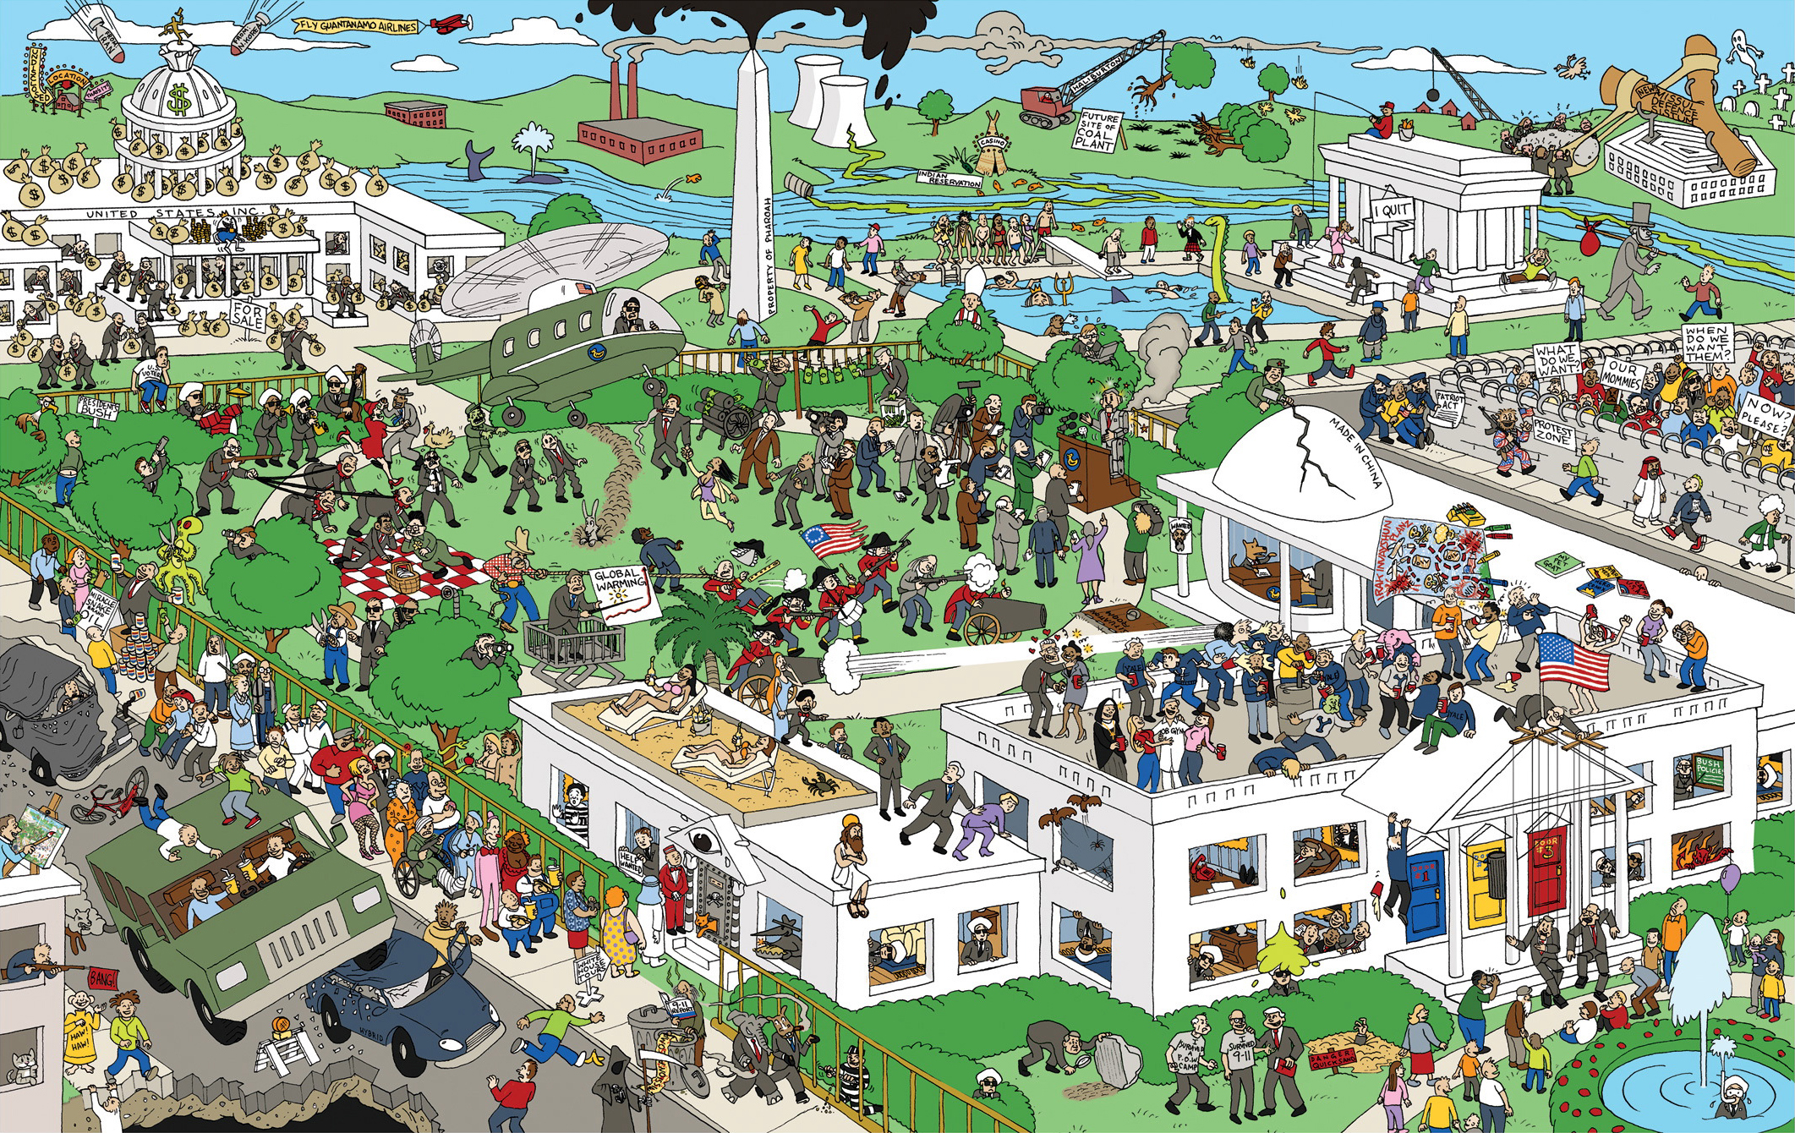
Can you find…
① a boy holding a purple balloon?
② a man sitting in a wheelchair?
③ a man wearing a red jacket playing a drum?

Level 3!

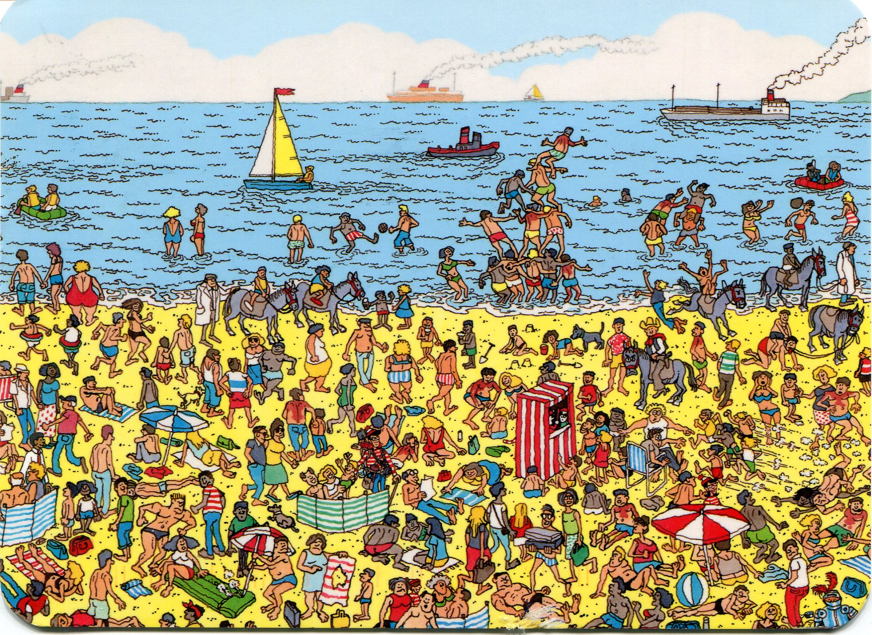
Can you find…
A man wearing a red and white striped shirt? (Wally)
① a woman riding a donkey?
② a man wearing glasses?
③ a man wearing red trousers?
Level 1!

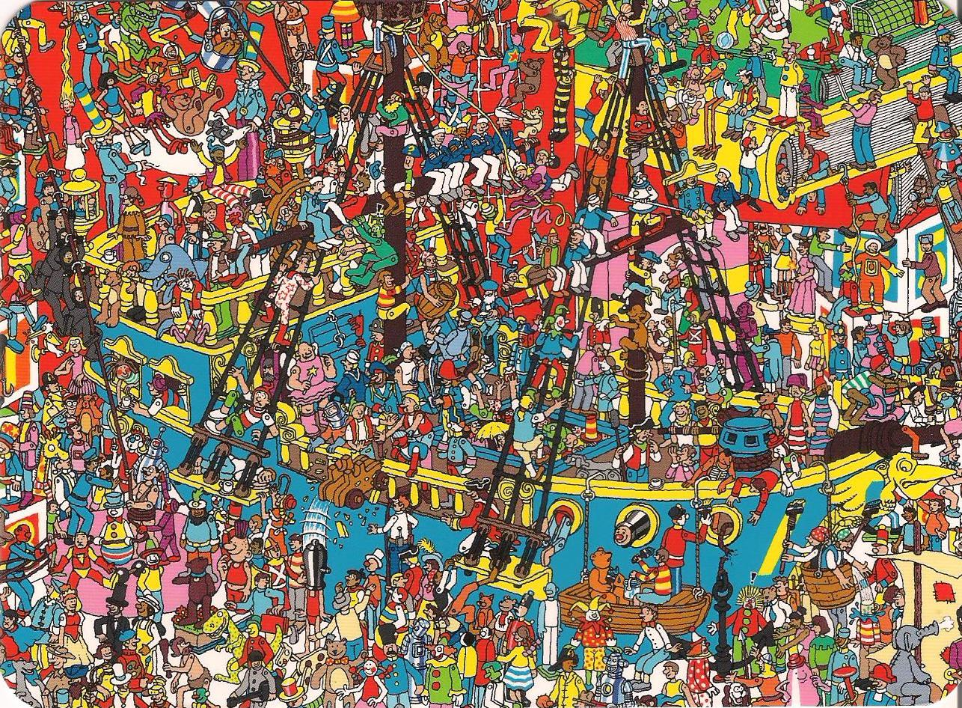

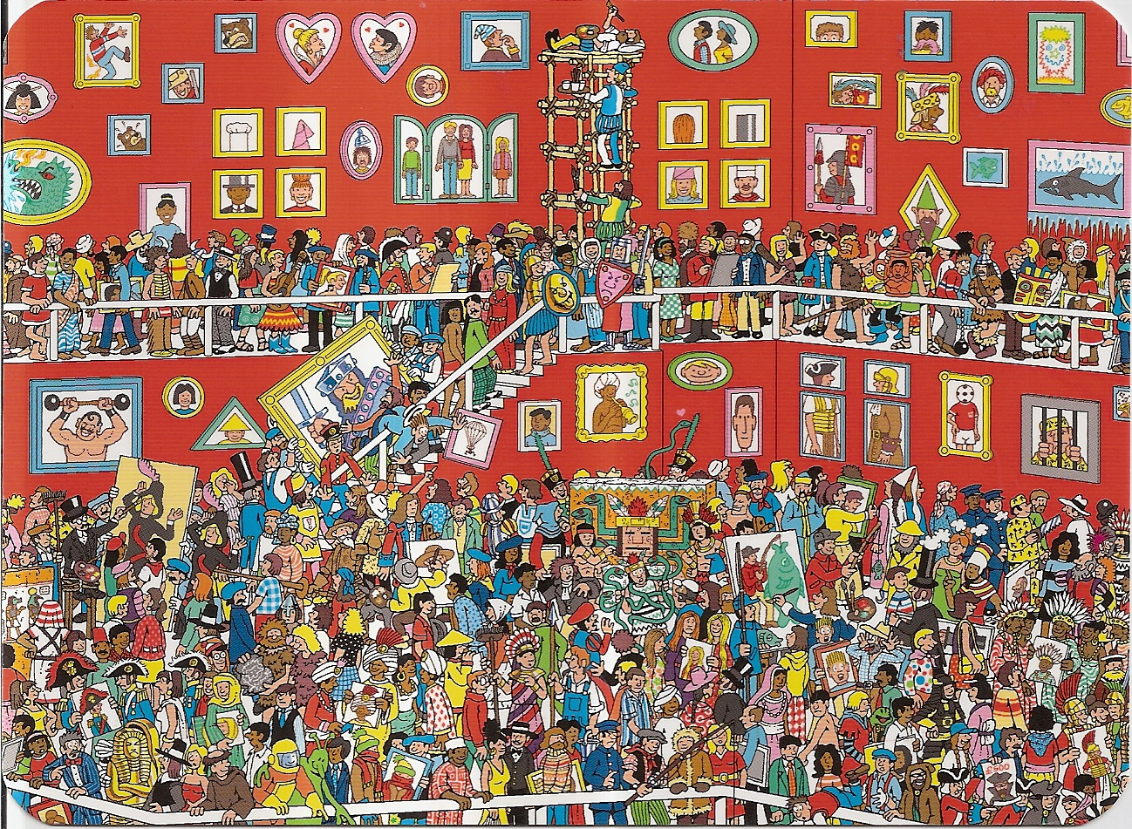

Name: Class: Date:
Where’s that man/woman??

Team Name:

例）Hey (Miss Nakazawa), can you find…? (a man wearing red trousers)
Round 1:___________________________________________________________________________

Round 2:___________________________________________________________________________

Round 3:___________________________________________________________________________

Vocabulary List 単語
How do you say ○○ in English? 英語で○○は何と言う？
絵 | Picture | はしご | ladder
ほうき | Broom | 大砲 たいほう | Cannon
槍 やり | Spear | なわ | Rope
盾 たて | shield | 船 | Boat
刀 | Sword | バレル・樽 たる | Barrel
絵筆 | Paintbrush | ひげ | beard
イヤリング | earring
How do you say this word? この言葉の発音は？

持っている holding 横たわる lying (on)
運転している driving (a) 座っている sitting (on)
乗っている riding (a) 描いているpainting
投げている throwing (a) 運んでいる carrying
飛んでいる jumping
追いかかっている chasing
着てる・履いている wearing

