

**Why ~?**

**Because … with Cony & Brown.**

**Activity 1: Match the question to the correct answer and picture.**

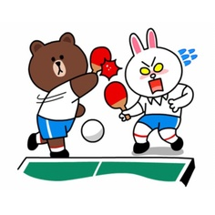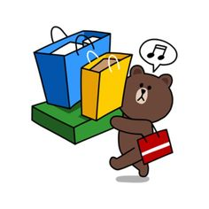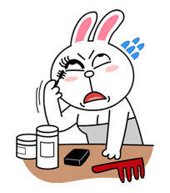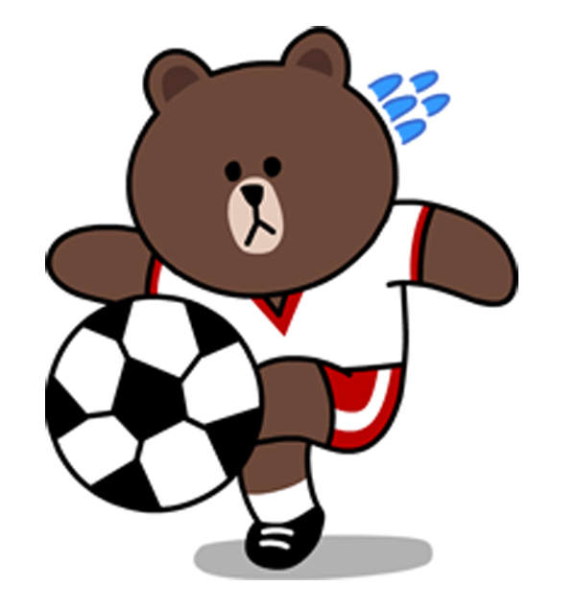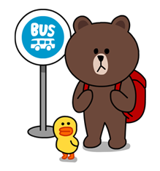

**Q: Why . . .**

**A. Because . . .**

**Activity 2: Choose a picture and create your own question and answer from the picture.**

1. Why is Cony laughing?

2. Why was Brown late for school?

3. Why is Cony tired?

4. Why is Brown at the park?

5. Why did Cony stay up late?

A. Because she was running at the gym.

B. Because she is watching something funny on TV.

C. Because he was waiting for the bus.

D. Because she was studying very hard.

E. Because he is playing soccer.