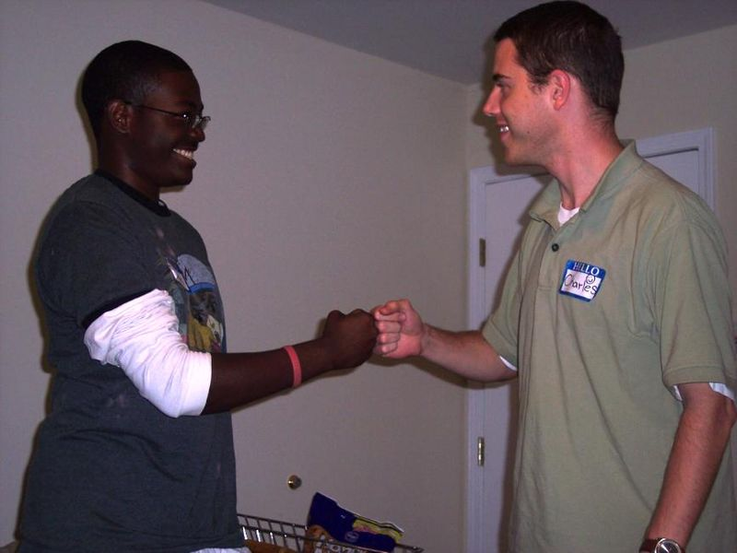 | 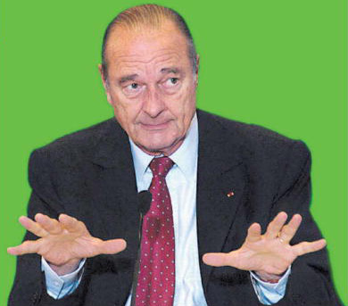 | 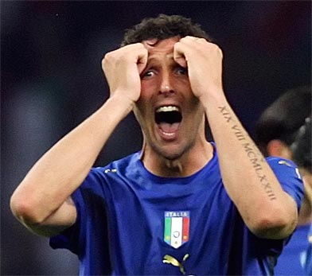
 |  | 
 |  | 
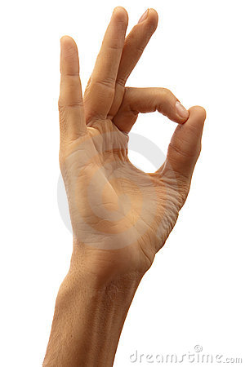 | 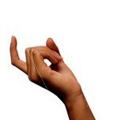 | 
 |  | 
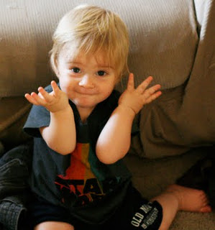 |  | 
World Gestures Lesson Plan

Name: Carol Pinnock
School: Tsunan Secondary School
Time: Usually 1 class, but can be extended to 2 classes and a speaking test
Materials: Flash cards, Karuta cards, dialogue with gestures handouts
Objectives: Listening, speaking, foreign culture, general communication, a little reading
Target: Usually OC classes, but I have also used with 2nd grade and up at my Chuto
Procedure: A few of the OC textbooks try to cover gestures but if this isn’t covered in the textbook you are using, it is still a good lesson for a textbook break or for a foreign culture class, or on a day when your JTE says ‘anything is fine.’ First, do a little research about gestures in Japan and other foreign countries. Here are a few interesting examples I found:
- In Bulgaria and Greece, nodding your head up and down means “No.”
- In Brazil and Germany, the OK gesture is considered obscene, while in France it means worthless or zero.
- In Europe, the ‘waving hello/goodbye’ gesture can mean ‘NO’, so it’s best to have your palm facing out and move your fingers up and down in unison when saying greeting.
Additionally, tell students an anecdote or two about when you just got here and saw for example the ‘come here’ gesture (looks like the western version of GO AWAY) and the ‘I don’t know gesture’, (waving hands in front of nose, which looks like our version of SMELLY). Tell students what you thought and how confused you were. Then show them a few gestures and ask them what they think it means, and does it mean the same thing in Japan. If it doesn’t, ask them to show you the Japan version. Once you have done that for a bit, break out the flash cards and teach them the gestures, then randomly select cards and elicit answers from the students to see if they remember the meanings. You can do this just as practice or competition style, it’s up to you.

Next is Karuta. Print a few sets of the cards provided and play Karuta with the students (I’m sure you all know how Karuta works), giving seals, stickers or whatever prizes you use, to the person from each team who has correctly identified and grabbed the most cards.

Next is the speaking and actual communication part. I have included 2 sets of possible dialogues, but you can look at the gestures and make up your own dialogues for pairs or even sets of three students. Also, please feel free to add gestures. In my dialogues there are gestures that did not feature in the flash card or Karuta section, but were in the text book I used, so I included them. You can change, add, or subtract gestures as you see fit.
Put students into pairs, give them one of the prepared ‘dialogue with gestures’ handouts, have them decide who is person A and who is person B and have them practice with each other for a little. Then select random pairs to come up and perform in from of the class. Usually, this part is the most fun, because students really get into using the gestures for real.

N.B. The flash cards are simply bigger A4 sized versions of the Karuta cards, so you can use the pictures
provided here to make those yourself, I didn’t include them.
Also, I mentioned using this as a speaking test above, so if for example gestures are covered in your OC
textbook, then you can use the dialogue as a speaking test where students take the test in pairs
demonstrating their ability to use the gestures while having a conversation.

Dialogue 1

A: Hi, __________. Do you have any money (gesture) I can borrow?
B: I can’t hear you (gesture). Please come here (gesture)
A and B: Hi (fist bump gesture)
A: I need some money (gesture) to buy an English textbook. I have a text next week.
B: Hmmm (gesture). OK (gesture) Here you are.
A: Thanks a lot. Wish me luck (gesture)
A and B: Goodbye (wave goodbye gesture)

Dialogue 2

A: Hello ________. What’s up?
B: Just a moment (gesture). I’m on the phone (gesture).
A: Oops! (gesture).
B: Sorry, I was trying to call Ken. Do you know where he is?
A: I don’t know (gesture)
B: Hmmmm (gesture). I wonder where he is. There is Maki, I’ll ask her
Hey! Maki …
A: Sssshhhh (gesture) there is a test going on over there.
B: Oops! (gesture) Well I’m going to go look for Ken.
A: OK, I hope you find him. See you later (A and B do the fist bump gesture).

