Glee Listening Quiz
“You only get what you give” by the New Radicals

Listen to the music and circle the correct answer:

Wake up kids we’ve got the dreamer’s disease
Age fourteen and we’ve got you down on your knees
So polite, you’re busy still saying please
Frenemies who when you’re down ain’t your friend
Every night we smash the Mercedes-Benz
First we run and then we laugh till we cry
But when the night is falling and you cannot find the light
If you feel your dream is dying hold tight.
You’ve got the music in you
Don’t let go
You’ve got the music in you
One dance left
The world is gonna pull through
Don’t give up
You’ve got a reason to live
Can’t forget you only get what you give
Four a.m. we ran a miracle mile
Were flat broke but hey we do it in style
The bad rich, God’s flying in for your trial

(Chorus)

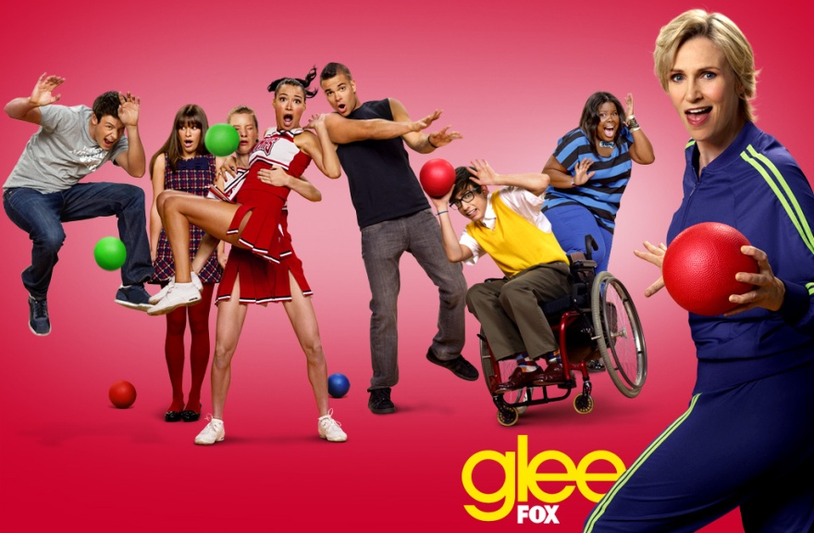

The whole damn world can fall apart
You’ll be okay, follow your heart
You’re in harm’s way, I’m right behind
Now say you’re mine

(Chorus)

Fly high, what’s real can’t die
You only get what you give
Just don’t be afraid to leave
Health insurance rip off lying fda big bankers buying
Fake computer crashes dining
Cloning while they’re multiplying
Fashion shoots with Beck and Hanson
Courtney Love and Marilyn Manson
You’re all fakes, run to your mansions
Come around, we’ll kick you’re … in
Don’t let go
One dance left

Glee Listening Quiz
“I’ll remember” by Madonna

